Nama : Muhammad Aqeel Jabbar

NIM : 6701220124

Kelas : D3SI-46-01

1. Profile

1. Buat Form

1. Buat fungsi

1. Membuat array

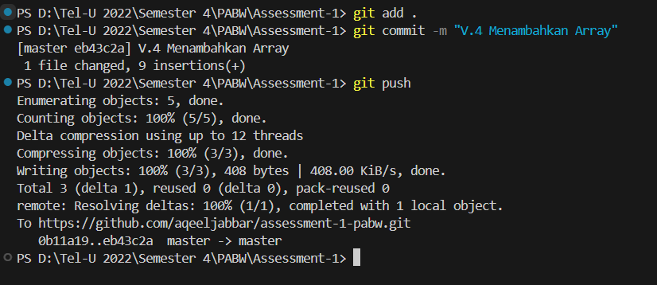

1. Cek field jumlah

1. Cari array nama

1. Validasi jumlah melebihi stok pada array

1. Validasi jumlah sesuai dengan stok buku

Versi Final

Hasil pengerjaan berada di master.

